Lab 09 – Worksheet

Name:Rushan Ali, Fardeen | ID: | Section:

Note: Assumptions and logics should be explained separately in tasks after the task results.

Task 1
Truth Table
a) Main Control Unit
b) ALU Control Unit

Instruction / Opcode RW AS MR MW M2R Br ALUOp
R-Type (0110011) 1 0 0 0 0 0 10
ADDI (0010011) 1 1 0 0 0 0 00
LW/LH/LB (0000011) 1 1 1 0 1 0 00
SW/SH/SB (0100011) 0 1 0 1 X 0 00
BEQ (1100011) 0 0 0 0 X 1 01

ALUOp funct3 f7[5] Operation ALUCtrl
00 XXX X Add (L/S/ADDI) 0010
01 XXX X Sub (BEQ) 0110
10 000 0 ADD (R-type) 0010
10 000 1 SUB (R-type) 0110
10 001 X SLL 0100
10 101 X SRL 0101
10 111 X AND 0000
10 110 X OR 0001
10 100 X XOR 0011

Comments

Task 2

Design Module Codes for Main Control Unit, and ALU Control Unit.
module TopModule (
input [15:0] sw,
output [15:0] led
);

wire [6:0] opcode;
wire [2:0] funct3;
wire funct7_5;

wire RegWrite;
wire ALUSrc;
wire MemRead;
wire MemWrite;
wire MemtoReg;
wire Branch;
wire [1:0] ALUOp;
wire [3:0] ALUControl_out;

// Connect switches to instruction fields
assign opcode = sw[6:0];
assign funct3 = sw[9:7];
assign funct7_5 = sw[10];

// Instantiate Main Control Unit (matching maincontrol.v)
maincontrol main_ctrl (
.opcode(opcode),
.RegWrite(RegWrite),
.ALUSrc(ALUSrc),
.MemRead(MemRead),
.MemWrite(MemWrite),
.MemtoReg(MemtoReg),
.Branch(Branch),
.ALUOp(ALUOp)
);

// Instantiate ALU Control Unit (matching Alucontrol.v)
Alucontrol alu_ctrl (
.ALUOp(ALUOp),
.funct3(funct3),
.funct7_5(funct7_5),
.ALUControl_out(ALUControl_out)
);

// Map control outputs to onboard LEDs
assign led[0] = RegWrite;
assign led[1] = ALUSrc;
assign led[2] = MemRead;
assign led[3] = MemWrite;
assign led[4] = MemtoReg;
assign led[5] = Branch;
assign led[9:6] = ALUControl_out;
assign led[11:10] = ALUOp;
assign led[15:12] = 4'b0000; // Unused LEDs

endmodule

module Alucontrol (
input [1:0] ALUOp,
input [2:0] funct3,
input funct7_5, // Bit 5 of funct7
output reg [3:0] ALUControl_out
);

always @(*) begin
case (ALUOp)
2'b00: ALUControl_out = 4'b0010; // ADD (for loads/stores & ADDI)
2'b01: ALUControl_out = 4'b0110; // SUB (for BEQ)
2'b10: begin // R-type operations
case (funct3)
3'b000: begin
if (funct7_5 == 1'b1)
ALUControl_out = 4'b0110; // SUB
else
ALUControl_out = 4'b0010; // ADD
end
3'b001: ALUControl_out = 4'b0100; // SLL[cite: 1]
3'b101: ALUControl_out = 4'b0101; // SRL[cite: 1]
3'b111: ALUControl_out = 4'b0000; // AND[cite: 1]
3'b110: ALUControl_out = 4'b0001; // OR[cite: 1]
3'b100: ALUControl_out = 4'b0011; // XOR[cite: 1]
default: ALUControl_out = 4'b0010;
endcase
end
default: ALUControl_out = 4'b0010;
endcase
end

endmodule

module maincontrol (
input [6:0] opcode,
output reg RegWrite,
output reg ALUSrc,
output reg MemRead,
output reg MemWrite,
output reg MemtoReg,
output reg Branch,
output reg [1:0] ALUOp
);

always @(*) begin
// Default assignments to prevent latches
RegWrite = 1'b0;
ALUSrc = 1'b0;
MemRead = 1'b0;
MemWrite = 1'b0;
MemtoReg = 1'b0;
Branch = 1'b0;
ALUOp = 2'b00;

case (opcode)
7'b0110011: begin // R-type (ADD, SUB, SLL, SRL, AND, OR, XOR)[cite: 1]
RegWrite = 1'b1;
ALUOp = 2'b10;
end
7'b0010011: begin // I-type Arithmetic (ADDI)[cite: 1]
RegWrite = 1'b1;
ALUSrc = 1'b1;
ALUOp = 2'b00;
end
7'b0000011: begin // I-type Load (LW, LH, LB)[cite: 1]
RegWrite = 1'b1;
ALUSrc = 1'b1;
MemRead = 1'b1;
MemtoReg = 1'b1;
ALUOp = 2'b00;
end
7'b0100011: begin // S-type Store (SW, SH, SB)[cite: 1]
ALUSrc = 1'b1;
MemWrite = 1'b1;
ALUOp = 2'b00;
end
7'b1100011: begin // B-type Branch (BEQ)[cite: 1]
Branch = 1'b1;
ALUOp = 2'b01; // Subtract for comparison
end
default: begin
// Safe defaults
end
endcase
end

endmodule

Testbench:
`timescale 1ns / 1ps

module tb_control_path();

// Testbench inputs
reg [6:0] opcode;
reg [2:0] funct3;
reg funct7_5;

// Outputs from Main Control
wire RegWrite;
wire ALUSrc;
wire MemRead;
wire MemWrite;
wire MemtoReg;
wire Branch;
wire [1:0] ALUOp;

// Output from ALU Control
wire [3:0] ALUControl_out;

// Instantiate Main Control Unit
maincontrol uut_main (
.opcode(opcode),
.RegWrite(RegWrite),
.ALUSrc(ALUSrc),
.MemRead(MemRead),
.MemWrite(MemWrite),
.MemtoReg(MemtoReg),
.Branch(Branch),
.ALUOp(ALUOp)
);

// Instantiate ALU Control Unit
Alucontrol uut_alu (
.ALUOp(ALUOp),
.funct3(funct3),
.funct7_5(funct7_5),
.ALUControl_out(ALUControl_out)
);

initial begin
// Initialize Inputs
opcode = 7'b0;
funct3 = 3'b0;
funct7_5 = 1'b0;

#20;
// 1. R-type: ADD[cite: 1]
opcode = 7'b0110011; funct3 = 3'b000; funct7_5 = 1'b0; #20;

// 2. R-type: SUB[cite: 1]
opcode = 7'b0110011; funct3 = 3'b000; funct7_5 = 1'b1; #20;

// 3. R-type: SLL[cite: 1]
opcode = 7'b0110011; funct3 = 3'b001; funct7_5 = 1'b0; #20;

// 4. R-type: SRL[cite: 1]
opcode = 7'b0110011; funct3 = 3'b101; funct7_5 = 1'b0; #20;

// 5. R-type: AND[cite: 1]
opcode = 7'b0110011; funct3 = 3'b111; funct7_5 = 1'b0; #20;

// 6. R-type: OR[cite: 1]
opcode = 7'b0110011; funct3 = 3'b110; funct7_5 = 1'b0; #20;

// 7. R-type: XOR[cite: 1]
opcode = 7'b0110011; funct3 = 3'b100; funct7_5 = 1'b0; #20;

// 8. I-type Arithmetic: ADDI[cite: 1]
opcode = 7'b0010011; funct3 = 3'b000; funct7_5 = 1'b0; #20;

// 9. I-type Load: LW / LH / LB[cite: 1]
opcode = 7'b0000011; funct3 = 3'b010; funct7_5 = 1'b0; #20;

// 10. S-type Store: SW / SH / SB[cite: 1]
opcode = 7'b0100011; funct3 = 3'b010; funct7_5 = 1'b0; #20;

// 11. B-type Branch: BEQ[cite: 1]
opcode = 7'b1100011; funct3 = 3'b000; funct7_5 = 1'b0; #20;

$finish;
end

endmodule

Waveforms:
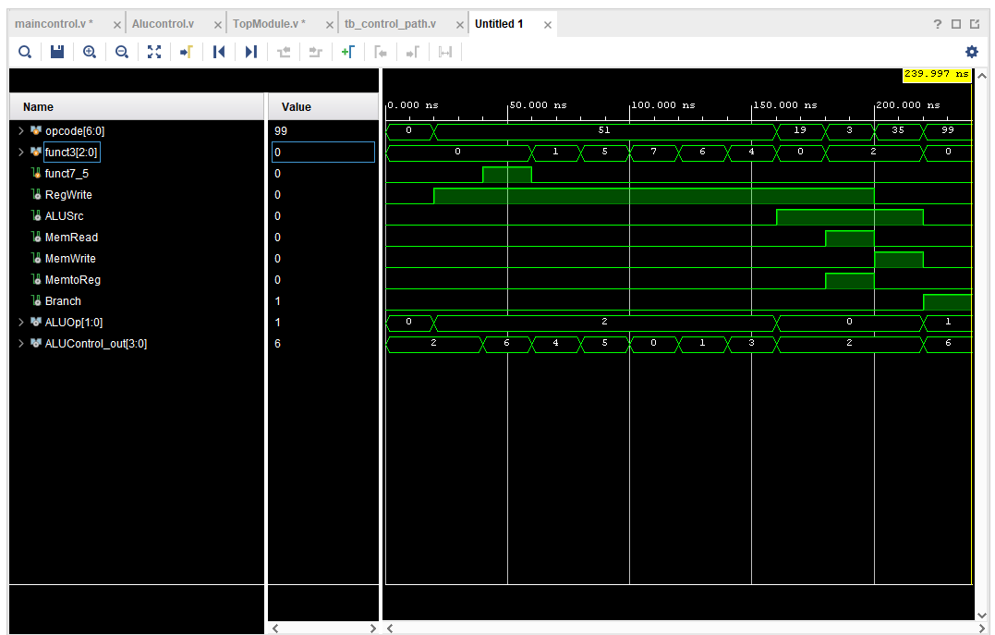

Task 3

Design module codes of top module:

module TopModule (
input wire clk,
input wire btnC,
input [15:0] sw,
output reg [15:0] led
);

wire [6:0] opcode = sw[6:0];
wire [2:0] funct3 = sw[9:7];
wire funct7_5 = sw[10];

wire w_RegWrite, w_ALUSrc, w_MemRead, w_MemWrite, w_MemtoReg, w_Branch;
wire [1:0] w_ALUOp;
wire [3:0] w_ALUControl_out;

// Instantiate Main Control Unit
maincontrol main_ctrl (
.opcode(opcode), .RegWrite(w_RegWrite), .ALUSrc(w_ALUSrc),
.MemRead(w_MemRead), .MemWrite(w_MemWrite), .MemtoReg(w_MemtoReg),
.Branch(w_Branch), .ALUOp(w_ALUOp)
);

// Instantiate ALU Control Unit
Alucontrol alu_ctrl (
.ALUOp(w_ALUOp), .funct3(funct3), .funct7_5(funct7_5),
.ALUControl_out(w_ALUControl_out)
);

FSM:
localparam [1:0] IDLE = 2'b00,
SAMPLE = 2'b01,
UPDATE = 2'b10;
reg [1:0] state = IDLE;

reg btn_sync0 = 0, btn_sync1 = 0;
always @(posedge clk) begin
btn_sync0 <= btnC;
btn_sync1 <= btn_sync0;
end
wire btn_pressed = btn_sync0 & ~btn_sync1;

always @(posedge clk) begin
case (state)
IDLE: if (btn_pressed) state <= SAMPLE;
SAMPLE: state <= UPDATE;
UPDATE: begin
led[0] <= w_RegWrite;
led[1] <= w_ALUSrc;
led[2] <= w_MemRead;
led[3] <= w_MemWrite;
led[4] <= w_MemtoReg;
led[5] <= w_Branch;
led[9:6] <= w_ALUControl_out;
led[11:10] <= w_ALUOp;
led[15:12] <= 4'b0000;
state <= IDLE;
end
default: state <= IDLE;
endcase
end
endmodule

Constraint file:
## Clock signal (100 MHz)
set_property PACKAGE_PIN W5 [get_ports clk]
set_property IOSTANDARD LVCMOS33 [get_ports clk]
create_clock -add -name sys_clk_pin -period 10.00 -waveform {0 5} [get_ports clk]

## Center Push Button (btnC)
set_property PACKAGE_PIN U18 [get_ports btnC]
set_property IOSTANDARD LVCMOS33 [get_ports btnC]

## Switches (sw[10:0])
set_property PACKAGE_PIN V17 [get_ports {sw[0]}]
set_property IOSTANDARD LVCMOS33 [get_ports {sw[0]}]
set_property PACKAGE_PIN V16 [get_ports {sw[1]}]
set_property IOSTANDARD LVCMOS33 [get_ports {sw[1]}]
set_property PACKAGE_PIN W16 [get_ports {sw[2]}]
set_property IOSTANDARD LVCMOS33 [get_ports {sw[2]}]
set_property PACKAGE_PIN W17 [get_ports {sw[3]}]
set_property IOSTANDARD LVCMOS33 [get_ports {sw[3]}]
set_property PACKAGE_PIN W15 [get_ports {sw[4]}]
set_property IOSTANDARD LVCMOS33 [get_ports {sw[4]}]
set_property PACKAGE_PIN V15 [get_ports {sw[5]}]
set_property IOSTANDARD LVCMOS33 [get_ports {sw[5]}]
set_property PACKAGE_PIN W14 [get_ports {sw[6]}]
set_property IOSTANDARD LVCMOS33 [get_ports {sw[6]}]
set_property PACKAGE_PIN W13 [get_ports {sw[7]}]
set_property IOSTANDARD LVCMOS33 [get_ports {sw[7]}]
set_property PACKAGE_PIN V2 [get_ports {sw[8]}]
set_property IOSTANDARD LVCMOS33 [get_ports {sw[8]}]
set_property PACKAGE_PIN T3 [get_ports {sw[9]}]
set_property IOSTANDARD LVCMOS33 [get_ports {sw[9]}]
set_property PACKAGE_PIN T2 [get_ports {sw[10]}]
set_property IOSTANDARD LVCMOS33 [get_ports {sw[10]}]

## LEDs (led[11:0])
set_property PACKAGE_PIN U16 [get_ports {led[0]}]
set_property IOSTANDARD LVCMOS33 [get_ports {led[0]}]
set_property PACKAGE_PIN E19 [get_ports {led[1]}]
set_property IOSTANDARD LVCMOS33 [get_ports {led[1]}]
set_property PACKAGE_PIN U19 [get_ports {led[2]}]
set_property IOSTANDARD LVCMOS33 [get_ports {led[2]}]
set_property PACKAGE_PIN V19 [get_ports {led[3]}]
set_property IOSTANDARD LVCMOS33 [get_ports {led[3]}]
set_property PACKAGE_PIN W18 [get_ports {led[4]}]
set_property IOSTANDARD LVCMOS33 [get_ports {led[4]}]
set_property PACKAGE_PIN U15 [get_ports {led[5]}]
set_property IOSTANDARD LVCMOS33 [get_ports {led[5]}]
set_property PACKAGE_PIN U14 [get_ports {led[6]}]
set_property IOSTANDARD LVCMOS33 [get_ports {led[6]}]
set_property PACKAGE_PIN V14 [get_ports {led[7]}]
set_property IOSTANDARD LVCMOS33 [get_ports {led[7]}]
set_property PACKAGE_PIN V13 [get_ports {led[8]}]
set_property IOSTANDARD LVCMOS33 [get_ports {led[8]}]
set_property PACKAGE_PIN V3 [get_ports {led[9]}]
set_property IOSTANDARD LVCMOS33 [get_ports {led[9]}]
set_property PACKAGE_PIN W3 [get_ports {led[10]}]
set_property IOSTANDARD LVCMOS33 [get_ports {led[10]}]
set_property PACKAGE_PIN U3 [get_ports {led[11]}]
set_property IOSTANDARD LVCMOS33 [get_ports {led[11]}]
set_property PACKAGE_PIN P3 [get_ports {led[12]}]
set_property IOSTANDARD LVCMOS33 [get_ports {led[12]}]
set_property PACKAGE_PIN N3 [get_ports {led[13]}]
set_property IOSTANDARD LVCMOS33 [get_ports {led[13]}]
set_property PACKAGE_PIN P1 [get_ports {led[14]}]
set_property IOSTANDARD LVCMOS33 [get_ports {led[14]}]
set_property PACKAGE_PIN L1 [get_ports {led[15]}]
set_property IOSTANDARD LVCMOS33 [get_ports {led[15]}]

RTL Schematic:
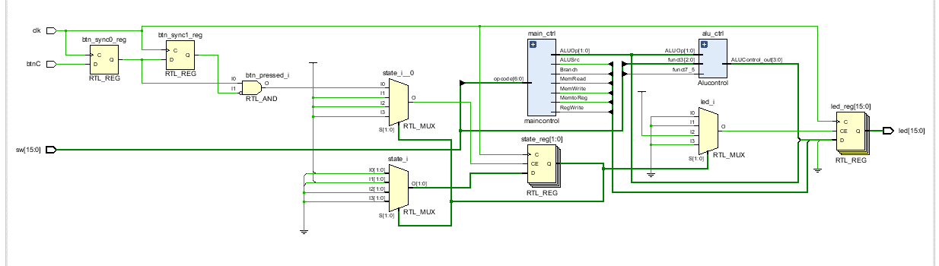

Lab 9: Design and FPGA Implementation of the Control Path for a Single-Cycle RISC-V Processor

Points Distribution
Task No. | LR2  Code | LR 5  Results | LR11  Design | AR7
Task 1 | - | - | /20 | /20
Task 2 | /20 | /15 |  | /20
Task 3 | /10 | /15 |  | /20
Total Points | /80 |  |  | /20
CLO Mapped | CLO 1
For description of different levels of the mapped rubrics, please refer the provided Lab Evaluation Assessment Rubrics and Affective Domain Assessment Rubrics.
# | Assessment Elements | Level 1: Unsatisfactory  Points 0-1 | Level 2: Developing  Points 2 | Level 3:Good  Points 3 | Level 4:Exemplary  Points 4
LR2 | Program/Code/ Simulation Model/ Network Model | Program/code/simulation model/network model does not implement the required functionality and has several errors. The student is not able to utilize even the basic tools of the software. | Program/code/simulation model/network model has some errors and does not produce completely accurate results. Student has limited command on the basic tools of the software. | Program/code/simulation model/network model gives correct output but not efficiently implemented or implemented by computationally complex routine. | Program/code/simulation /network model is efficiently implemented and gives correct output. Student has full command on the basic tools of the software.
LR5 | Results & Plots | Figures/ graphs / tables are not developed or are poorly constructed with erroneous results. Titles, captions, units are not mentioned. Data is presented in an obscure manner. | Figures, graphs and tables are drawn but contain errors. Titles, captions, units are not accurate. Data presentation is not too clear. | All figures, graphs, tables are correctly drawn but contain minor errors or some of the details are missing. | Figures / graphs / tables are correctly drawn and appropriate titles/captions and proper units are mentioned. Data presentation is systematic.
AR9 | Report | All the in-lab tasks are not included in report and / or the report is submitted too late. | Most of the tasks are included in report but are not well explained. All the necessary figures / plots are not included. Report is submitted after due date. | Good summary of most the in-lab tasks is included in report. The work is supported by figures and plots with explanations. The report is submitted timely. | Detailed summary of the in-lab tasks is provided. All tasks are included and explained well. Data is presented clearly including all the necessary figures, plots and tables.

